Steakhouse Breakfast Sandwich
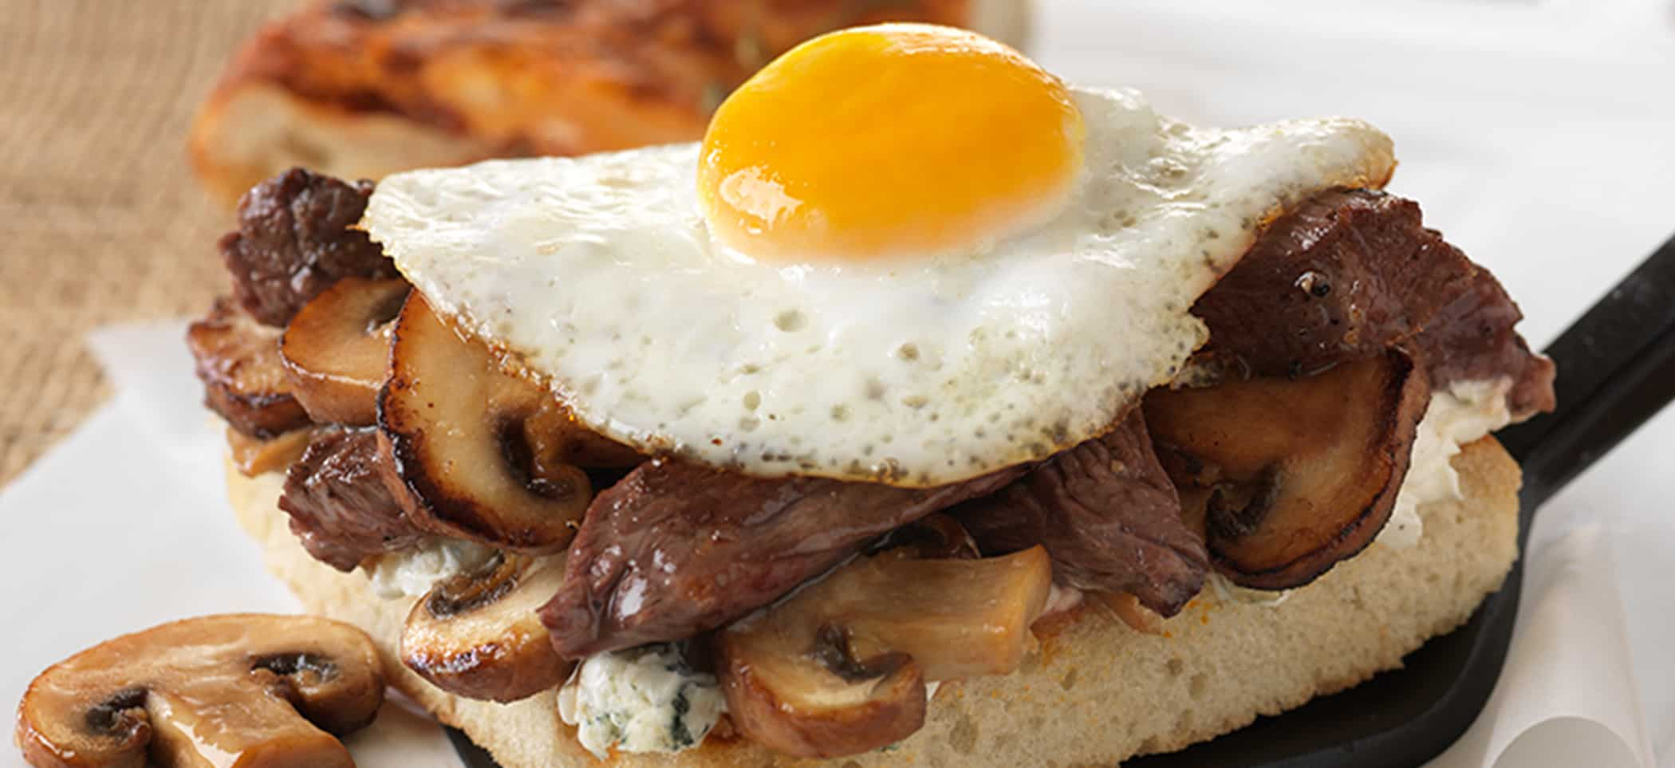
Ingredients (Blue Cheese Spread):
Blue Cheese crumbles | 8oz (1 ½ cups)
Softened cream cheese | 6oz
Sour cream | ¼ cup
Kosher salt | ½ tsp
Freshly ground black pepper | To taste

Directions:
- Beat all ingredients together until smooth. Chill.
For the Steak Tips
Butter (for sauteing)
Beef top sirloin steak, cut into thin strips | 2lb
Phil’s Fresh Cage-Free Large Eggs | 12
Half sheets of Asiago cheese focaccia, each cut into 12 squares | 2

Directions:
- For each serving: heat butter in saute pan over medium high heat
- Sear 2 ½ ounces sirloin steak strips, season with salt and pepper and saute until thoroughly cooked. Keep warm
- For each sandwich, cook one large egg over medium heat in spray-coated nonstick pan until white is set and yolk begins to thicken, but is not hard.
- Flip over and cook briefly on other side for additional firmness.
Ingredients (Sauteed Mushrooms):
Butter | 1oz
Shallots | 1 tbsp
Assorted mushrooms (buttons, creminis, and portobellos) | 12oz
Salt and pepper | To taste

Directions:
- Melt 1 ounce butter in large saute pan
- Add shallots and mushrooms, season with salt and pepper
- Cook until mushrooms have softened. Keep warm.
Sandwich Assembly Directions:
- Split focaccia and grill the cut sides until warm.
- Cover bottom slice with 3 tablespoons blue cheese spread
- Top with 2 tablespoons sauteed mushrooms, steak strips, and fried eggs
- Cover with focaccia top. Serve immediately
- Note: Do not allow raw or cooked eggs to remain at room temperature for longer than 1 hour (including preparation and service time)

