Topiary’s Colorful Slaw Salad
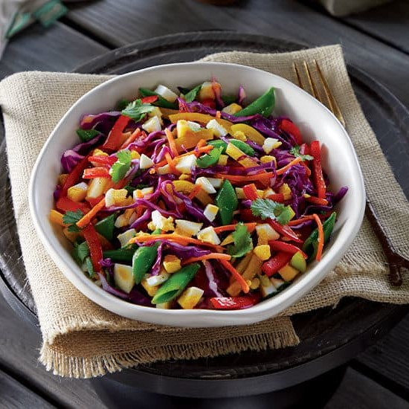
Ingredients:
4 | Phil’s Large DHA Omega-3 Eggs
¼ cup | Olive oil
2 tbsp | Honey
3 tbsp | Lime juice
1 tbsp | White wine vinegar
1 tsp | Cumin
½ tsp | Salt
¼ tsp | Pepper
2 cups | Red cabbage, shredded
1 cup | Carrot, shredded
1 cup | Sugar snap peas, cut into thirds
¼ cup | Green onions, sliced
½ cup | Red bell pepper, sliced and halved
½ cup | Yellow bell pepper, sliced and halved
½ cup | Cilantro, chopped

Directions:
- Place eggs in a large saucepan and cover with cool water. Bring to a boil, then remove from heat and cover with a lid. Allow eggs to sit in pan for 12 minutes, then transfer eggs to an ice bath, using a slotted spoon. Once eggs are cool, peel eggs and chop into ½ inch pieces and set aside.
- In a small bowl, whisk together olive oil, honey, lime juice, vinegar, cumin, salt, and pepper
- In a medium bowl, combine cabbage, carrot, snap peas, green onions, red bell pepper, yellow bell pepper, cilantro and chopped egg. Toss with dressing.
- Refrigerate leftovers for up to 4 days

