Meringue nests with vanilla bean whipped cream and strawberries

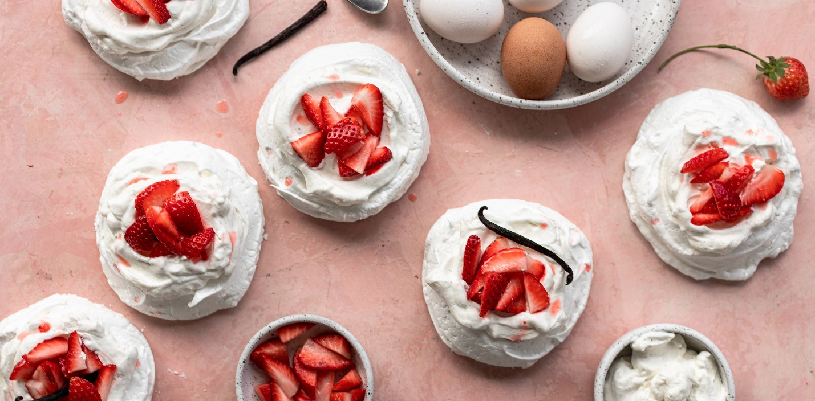

For the meringue nests

|  |  |
| --- | --- |
| 6 | Phil’s fresh large eggs |
| 1 ¼ cups | Granulated sugar |
| 1 tsp | Cream of tartar |
| 1 tsp | Vanilla extract |
| 2 tsp | Corn starch |

Directions:

1. Preheat oven to 200F. Spread the sugar evenly on a parchment lined baking sheet and bake in the oven for 5-7 minutes to slightly heat. Remove the sugar from the oven, then raise the oven temp to 225F
2. Carefully separate the egg whites from the yolks. If even a little bit of egg yolk gets into your mixing bowl, the whites won’t whip. In the bowl of a hand or stand mixer fitted with the whip attachment whisk the egg whites on low-medium speed until foamy. About 1 minute.
3. Slowly start adding the sugar, 2-3 tbsp at a time and mix on medium speed for 2 minutes in between each addition. The sugar needs to be completely mixed in to the egg whites to ensure recipe success. Do not rush the process. You can check that the sugar has been mixed in by squeezing some meringue between your fingers. If it does not feel gritty, it is ready. If it feels gritty, continue mixing on medium until mixed through.
4. When all of the sugar has been mixed in, add in the cream of tartar, vanilla extract, and corn starch. Raise to high sped and beat until stiff peaks form.
5. On 2 parchment paper lined baking sheets, pipe or spread the meringue with a spoon into 6, 4 inch circular “nests”
6. Bake for 1 hour 15 minutes. Then turn off the oven and let the meringues cool down inside. Do not open the door for at least 4 hours. You can also let them cool overnight.

For the garnish:

|  |  |
| --- | --- |
| 1 cup | Heavy whipping cream |
| 1 tsp | Granulated sugar |
| ½ tsp | Vanilla extract or 1 vanilla bean scraped |
| ½ pint | Fresh strawberries, sliced |

Directions:

1. When ready to serve, whip 1 cup of heavy whipping cream on medium speed in a clean mixing bowl fitted with the whip attachment. Slowly add in the sugar and the vanilla (extract, or seeds). Continue mixing on high speed until stiff peaks form. About 2-3 minutes
2. Dollop the whip cream on the meringue nests and top with sliced strawberries.