How to make hard boiled eggs
- Place eggs in saucepan large enough to hold them in single layer. Add cold water to cover eggs by 1 inch. Heat over high heat just to boiling
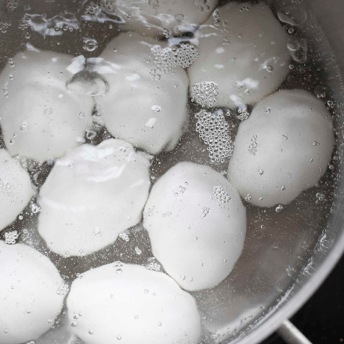
- Remove from burner. Cover pan. Let eggs stand in hot water about 12 minutes for large eggs (9 minutes for medium eggs; 15 minutes for extra large)
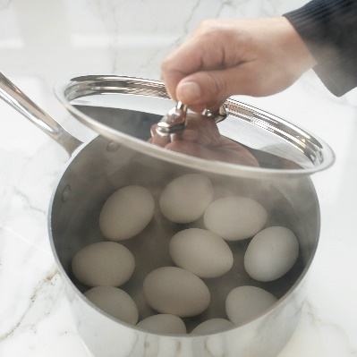
- Drain immediately and serve warm. Or cool completely under cold running water or in bowl of ice water, then refrigerate.
