Heavenly Deviled Eggs
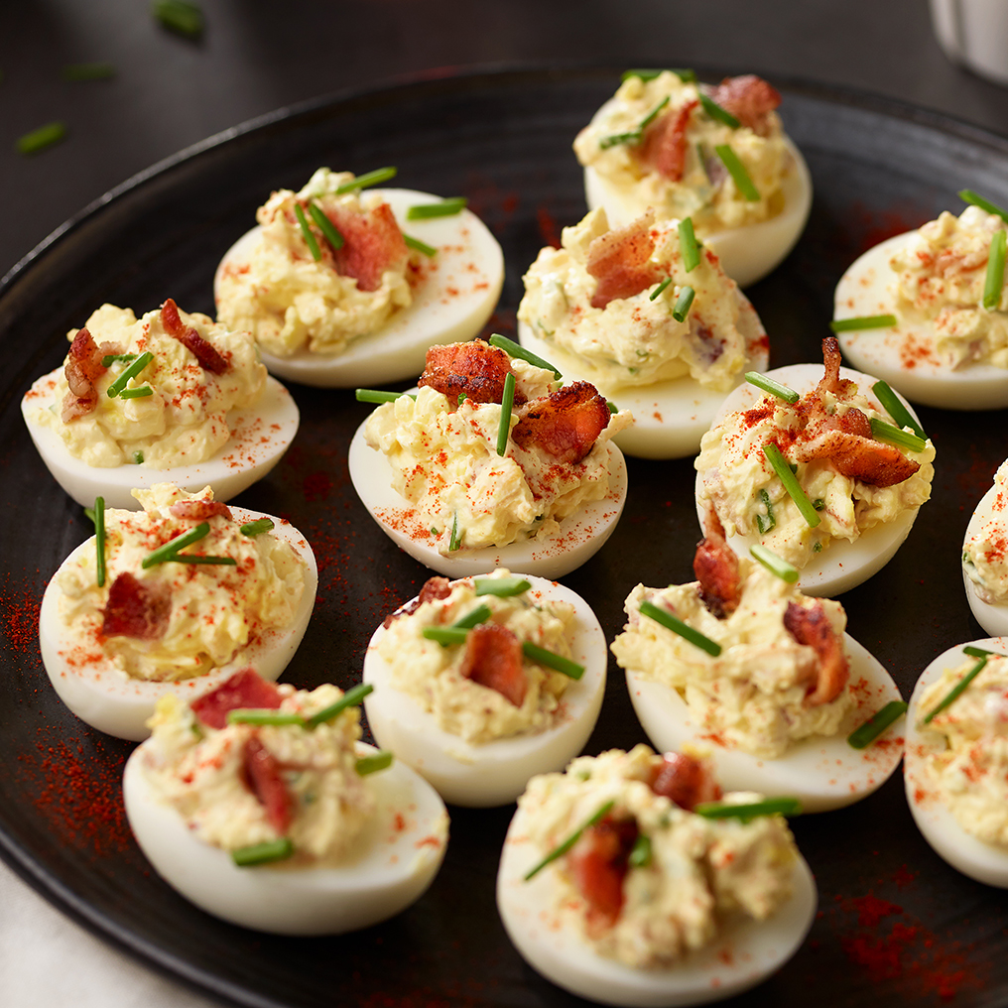
Ingredients:
Phil’s Fresh Free Range Eggs, Hard Boiled | 14
Mayonnaise | ½ cup
Sour cream | ½ cup
Dijon mustard | 1 ½ tsp
Fresh lemon juice | 1 tsp
Crumbled cooked bacon | 1/3 cup
Finely shredded sharp cheddar cheese | ¼ cup
Chopped fresh chives | 2 tbsp

Directions:
- Cut eggs lengthwise in half. Remove yolks to medium bowl. Reserve 24 white halves. Finely chop remaining four white halves and set aside.
- Mash yolks with a fork. Add mayonnaise, sour cream, mustard, lemon juice and pepper; Mix well. Add chopped egg whites, bacon, cheese and chives. Mix well
- Spoon 1 tbsp. yolk mixture into each reserved egg white half. Refrigerate, covered to blend flavors. Sprinkle with paprika just before serving if desired.

