Easter Bunny Meringue Carrot Cookies
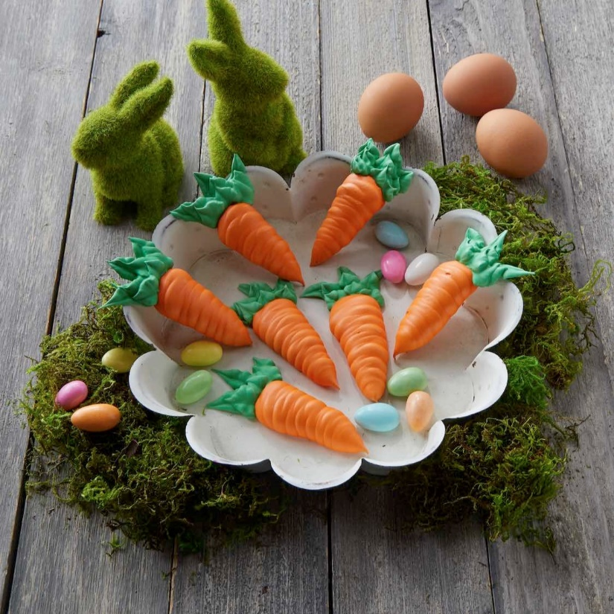
Ingredients:
Phil’s Fresh Free Range Egg Whites, room temperature | 3
Cream of tartar | ½ tsp
Powdered Sugar, plus extra if needed | 1 ½ cups
Vanilla | 1 tsp
Orange and green food coloring

Directions:
- Using a stand mixer with a whisk attachment or a hand mixer and a large bowl, beat the egg whites and cream of tartar at a high speed until foamy. Add the powdered sugar 1 tablespoon at a time, until the mixture is glossy and has stiff peaks, adding extra sugar if needed to get a stiff meringue. Add the vanilla.
- Line two baking sheets with parchment paper and lightly spray them with non-stick spray
- Divide the mixture- adding orange food coloring to 2/3rd of the meringue and adding the green food coloring to 1/3rd of the meringue. Put them in separate piping bags. On the baking sheets, with a medium open tip, pipe the orange meringue in the shape of a carrot about 2” long, starting at the base and pulling away from the paper for the tip (you should get about 30.)
- With the green meringue and a leaf tip, make 2-3 carrot tops attached to the carrot. Bake both sheets on two racks at 225F for 40-50 minutes. They should be mostly dry. Turn off the oven and let them cool inside the oven.

