Coconut Cream Pie with Coconut Meringue
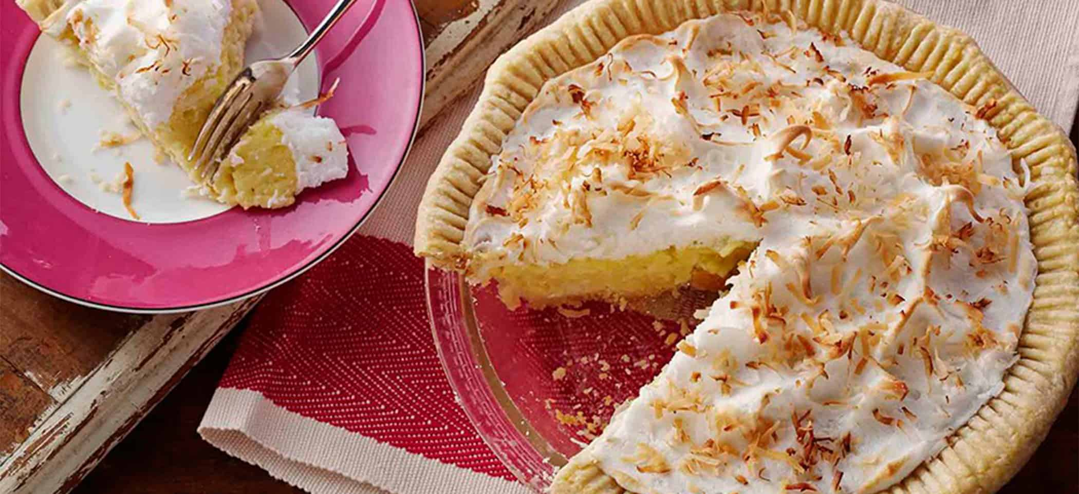
Ingredients:
Basic egg & lemon juice pie crust (9-inch), baked, cooled | 1
Phil’s Large Free Range Brown Egg Yolks | 5
Sweetened coconut milk beverage | 2 ½ cups
Sugar | ½ cup
Corn starch | 1/3 cup
Salt | ¼ tsp
Vanilla | 1 tsp
Flaked coconut | 1 cup
Phil’s Large Free Range Brown Egg Whites, room temperature | 5
Corn starch | 1 tbsp
Cream of tartar | ¼ tsp
Sugar | ½ cup
Vanilla | ½ tsp
Flaked coconut | ¼ cup

Directions:
- Heat oven to 325F. Filling: beat egg yolks in medium bowl; gradually stir in coconut milk until blended. Mix sugar, corn starch and salt in large heavy saucepan. Gradually stir in egg yolk mixture until blended
- Cook over medium-low heat, stirring constantly, until mixture thickens and comes to a boil, 10-15 minutes. Boil and stir 1 minute. Remove from heat immediately. Stir in vanilla and coconut.
- Immediately make Meringue: dissolve corn starch in cold water in one-cup glass measure. Microwave on high 30 seconds; stir. Microwave until mixture boils, 15-30 seconds longer. Remove; cover.
- Beat egg whites and cream of tartar in mixer bowl with whisk attachment on high speed until foamy. Beating constantly, add sugar, 1 tbsp. at a time, beating after each addition until sugar is dissolved before adding the next. Continue beating until whites are glossy and stand in soft peaks. Beating constantly, add corn starch paste, 1-2 tbsp. at a time. Beat in vanilla.
- Pour hot filling into pie crust. Quickly spread meringue evenly over filling, starting at edge and sealing to crust all around; swirl with back of spoon. Sprinkle with ¼ cup coconut. Bake upper third at 325F oven until lightly browned, 16-18 minutes. Cool on wire rack for 1 hour, then refrigerate 3-4 hours before serving.

