Carrot Cake Cinnamon Buns
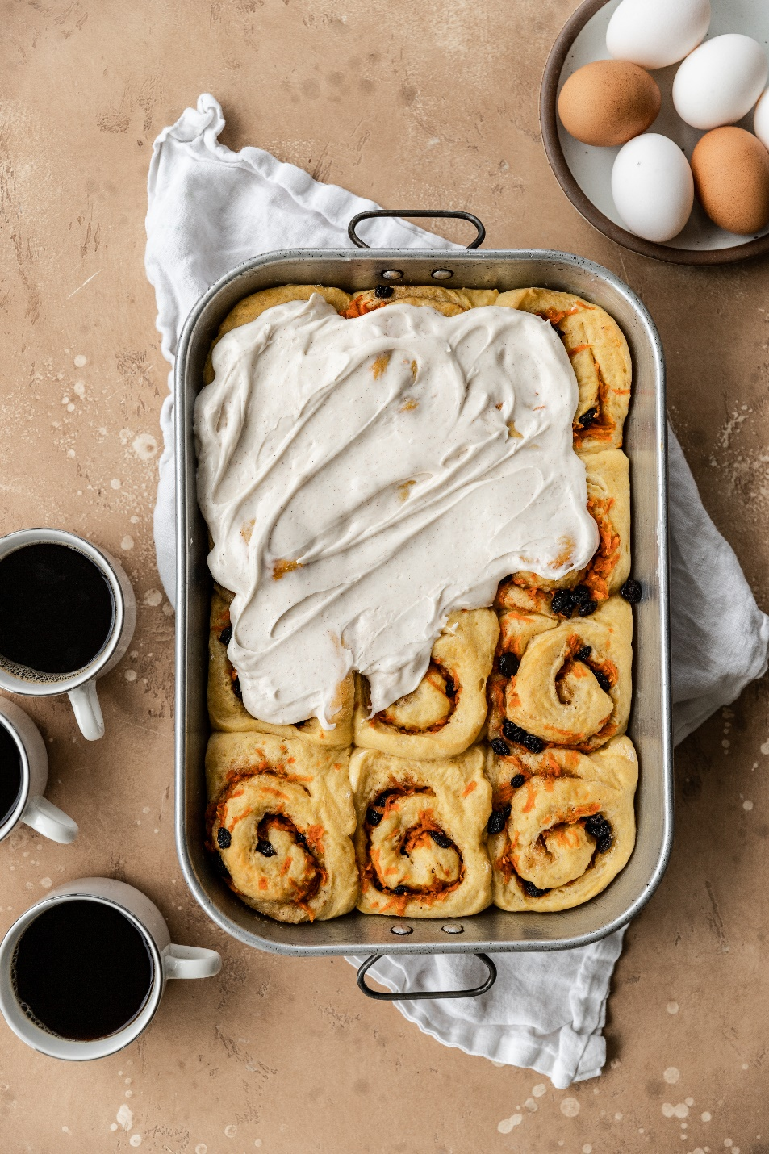

Ingredients:
Milk | 8oz
Active dry yeast | 2 ¼ oz packs
Sugar | ½ cup
Phil’s Fresh Free Range Brown Eggs | 3
Pureed carrot baby food | 2 oz
Bread or all purpose flour | 5-5 1/2 cup
Kosher salt | ½ tsp
Unsalted butter, softened | ¼ cup

Directions:
- In a microwave safe measuring cup, heat the milk for 30 seconds at a time till warmed throughout but not boiling. Add the milk to the bowl of a stand mixer. Add the yeast and the sugar, stir lightly and let sit for 10 minutes until frothy.
- Whisk in the eggs one at a time until incorporated before adding the next. Then add in the baby food and whisk to combine
- Add the flour and salt to the bowl and using the dough hook, mix on low, moving up to medium speed for 2 minutes. Add in the softened butter and continue to mix for 4 more minutes. You may have to scrape down the sides of the bowl half way through. If the dough is very sticky, add up to ½ cup flour in small increments. The finished dough will be slightly sticky, that’s okay!
- Place the bowl in a warm spot covered with a tea towel to rise for 2 hours
- When the dough has doubled in size, knead the dough on a floured surface until no longer sticky. Then, roll it out into approximately an 18” x 22” rectangle
For the filling:
Ingredients:
Very soft butter | 1/3 cup
Brown sugar | 1/3 cup
Ginger | ¼ tsp
Nutmeg | ½ tsp
Ground cinnamon | 1 tbsp
Raisins | ½ cup
Medium carrots | 2, hand grated, should total about 1- 1 ½ cups

Directions:
- Brush the dough with softened butter, leaving a 1” border free. Sprinkle with brown sugar, ginger, nutmeg, cinnamon, raisins, and the shredded carrots. Make sure to squeeze the carrots dry as to not add any excess water to the recipe
- Rolle the dough on the long end into a log and cut off the ends and discard. Cut the log into 15 1-1 ½ inch spirals. Place in a greased 9x13 inch pan and leave to rise again for 1 hour in a warm spot covered with a tea towel
- Preheat the oven to 350F and bake the buns for 20-25mins or until they are golden brown on top
For the glaze:
Ingredients:
Cream cheese, softened | ½ cup
Unsalted butter, softened | ¼ cup
Confectioners sugar | 2 ½ cup
Cinnamon | 1 tsp
Milk | 1 ½ tbsp

Directions:
- Combine the cream cheese and butter in a large bowl and stir with a sturdy spatula. Add the confectioners sugar, cinnamon, and milk. Stir until a pourable glaze forms
- Pour over the warm cinnamon buns and enjoy

