Blazing Poblano Burger
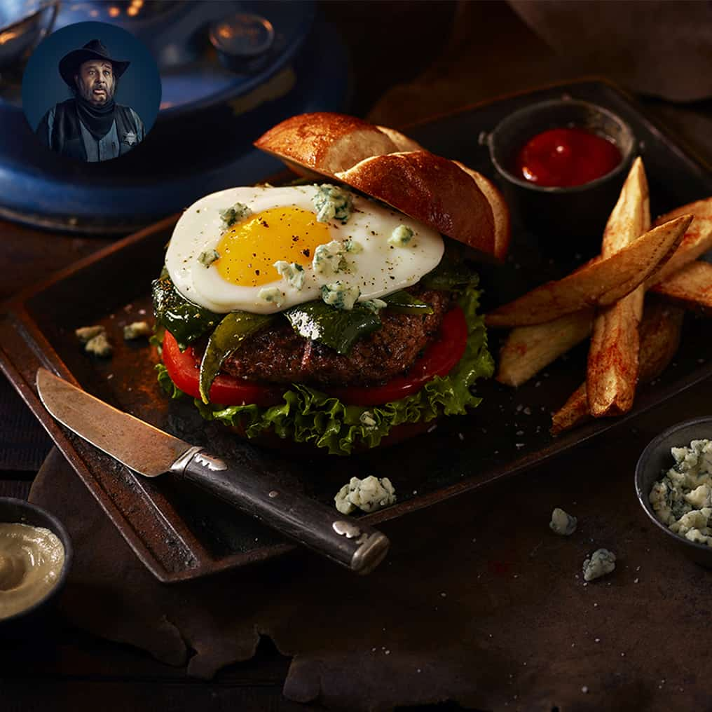

Ingredients:
Phil’s Fresh DHA Omega-3 Large Eggs | 4
Poblano Peppers | 2
Lean Ground Beef | 1lb
Onion, finely chopped | ½ cup
Garlic pepper | 1 tbsp
Paprika | ½ tsp
Cayenne Pepper | ¼ tsp
Salt | 1 tsp
Pepper | 1 tsp
Pretzel buns | 4
Lettuce Leaves | 4
Tomato, sliced | 1
Blue cheese, crumbled | ¼ cup

Directions:
- Place poblano peppers over a medium-high flame or a skillet on medium high setting. Turning on all sides with tongs to roast evenly. Skin should be blistered and lightly charred. Immediately place roasted peppers in a plastic bag. Seal bag and steam for 10 minutes.
- Spray a fry pan with coking oil and heat to medium-high. Break eggs one at a time, and cook until desired doneness. Cover and keep on very low heat
- Remove peppers from bag and rub off charred skin with fingers or a paper towel. Skin will peel off easily. Remove poblano stems and seeds. Slice open and scrape veins and remaining seeds with a small knife. Slice in large strips. Keep warm.
- In the meantime, place ground beef in a medium bowl. Add onion, garlic powder, paprika, cayenne pepper, salt and pepper. Mix with hands until all ingredients have combined. Divide into 4 patties.
- Grill or cook patties in a cast iron skillet on stove top for 3-5 minutes on each side.
- Place cooked patties on bottoms of sliced pretzel buns. Add lettuce, tomato, pepper strips, blue cheese and top with fried egg and pretzel bun top.

