Basic French Toast
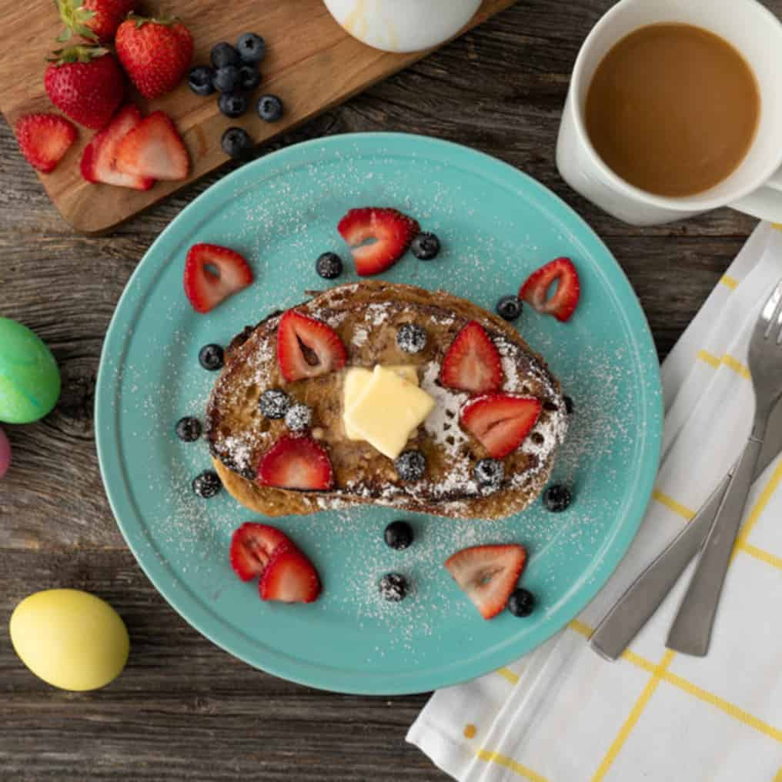
Ingredients:
Phil’s Fresh Cage Free Eggs | 8
Milk | 1/3 cup
Ground nutmeg, OPTIONAL | ¼ tsp
Day Old Bread | 8 slices

Directions:
- Beat eggs, milk and nutmeg in shallow dish until blended. Soak one bread slice at a time in egg mixture, turning once, letting stand about 1 minute per slice
- Heat lightly greased large nonstick skillet over high heat until hot
- Place as many bread slices in hot pan as will fit in single layer. Immediately reduce heat to medium. Cook until golden brown and no visible liquid egg remains, 2-3 minutes per side. Repeat to cook remaining bread. Serve immediately.

