Basic Cheese Quiche
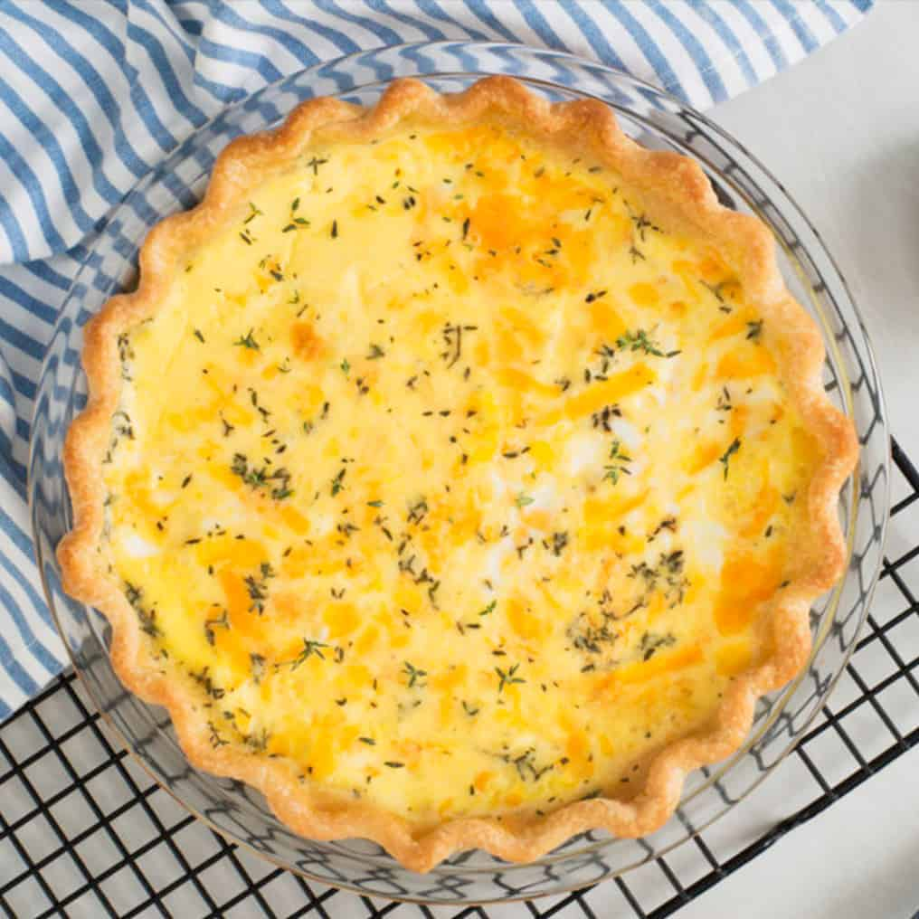
Ingredients:
Shredded cheese | ½ to 1 cup
Basic egg & lemon juice pie crust (9-inch), baked | 1
Filling | ½ to 1 cup
Phil’s Fresh DHA Omega-3 Eggs | 6
Milk | 1 cup
Dried thyme leaves or other herb | ½ tsp
Salt | 1 tsp

*Make filling from your favorite foods or leftovers. Use a combo of cheese, meat, seafood or poultry and vegetables
Directions:
- Heat oven to 375F. Spread cheese evenly in bottom of piecrust. Top with filling in an even layer
- Beat eggs, milk, salt and thyme in medium bowl until blended. Carefully pour over filling in piecrust
- Bake in center of 375F oven until center is almost set but jiggles slightly when dish is gently shaken and knife inserted near center comes out clean, 30-40 minutes. Let stand 5 minutes. Cut into wedges.

