Banana Chocolate Crepes
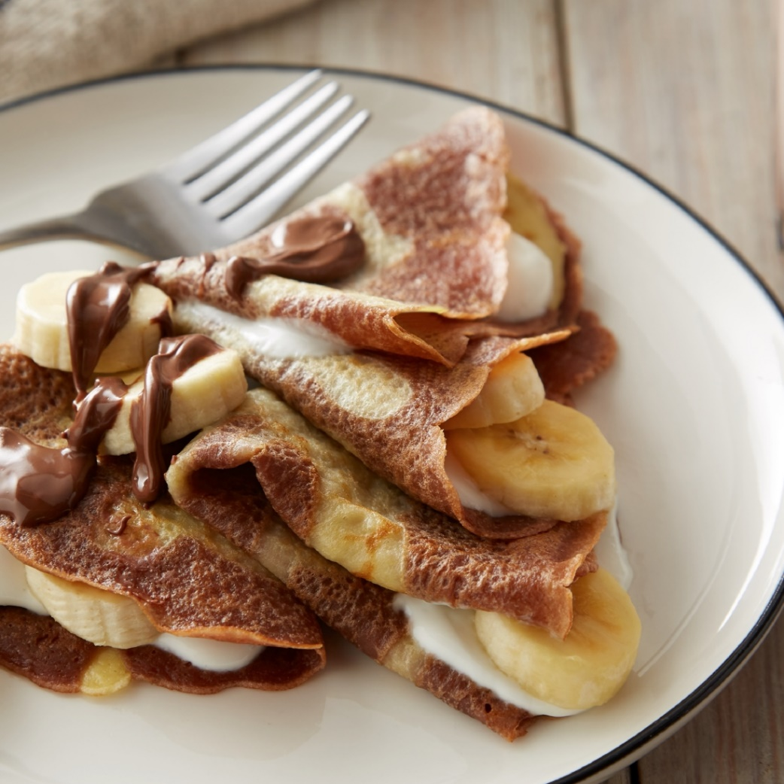
Ingredients:
Phil’s Fresh Pasture Raised Eggs | 3
Milk | 1 ¼ cup
Salt | ¼ tsp
Sugar | 2 tsp
Vanilla | 1 tsp
Butter, melted and divided | 4 tbsp
Flour | 1 cup
Nutella, softened, plus additional for garnish | 2 tbsp
Vanilla Greek yogurt | 1 cup
Bananas | 3

Directions:
- In a medium bowl, whisk eggs, milk, salt, sugar and vanilla. When it is combined, add the flour and then 3 tablespoons of butter. Cover and let rest for 20 minutes (or overnight in the fridge). Divide the batter between two bowls and add the softened Nutella to one half of the batter.
- Heat an 8-9 inch nonstick skillet over medium high heat. Brush with some of the remaining melted butter and drizzle 1-2 tablespoons of the Nutella batter in the buttered pan and then add ¼ cup plain batter over it and tip the pan to spread the batter. Cook 50-60 seconds until lightly brown and gently flip over. Cook the other side. Repeat with remaining butter and batter drizzling the plain batter and covering it with the Nutella batter.
- Stack crepes on a plate and cover with a second plate to keep them from drying out. Fill crepes with vanilla Greek yogurt, sliced bananas and top with additional Nutella if desired.

