Avocado & Potato Hash with Sunny Side Eggs
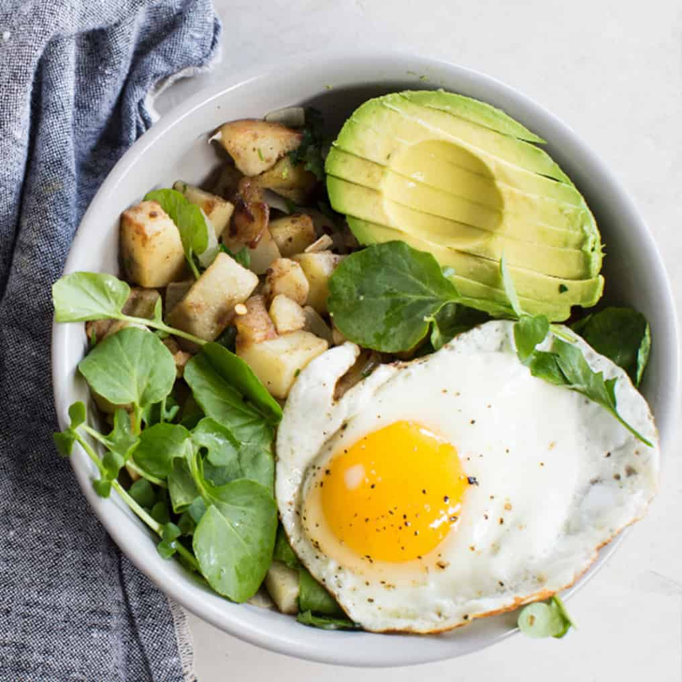
Ingredients:
1 tbsp | Extra virgin Olive oil
4-5 | Medium Mozart potatoes (red skin with yellow flesh), peeled and medium diced
½ cup | White onions, small diced
Pinch | Crushed red pepper flakes
2 | Avocados, large, diced medium
1 tsp | Fresh lemon juice
1 tbsp | Fresh parsley
1 tsp | Kosher salt
8 | Phil’s Fresh Large DHA Omega-3 Eggs
3 tbsp | Unsalted butter
Radishes, thinly sliced, hold in ice water to crisp | ¼ cup
Microgreens to garnish

Directions:
- In a large saute pan, heat oil and add potatoes. Cook over medium heat stirring occasionally for 8-9 minutes
- Add onions, red pepper flakes, and avocados. Continue to cook for another 6-7 minutes until potatoes are tender
- Add lemon juice, parsley, and salt
- In another large saute pan, cook eggs sunny side up in butter, season with salt and pepper
- Divide potato hash and avocado among four plates or shallow bowls, and top each portion with two eggs. Garnish with radishes and microgreens.

