Southern Deviled Egg Salad
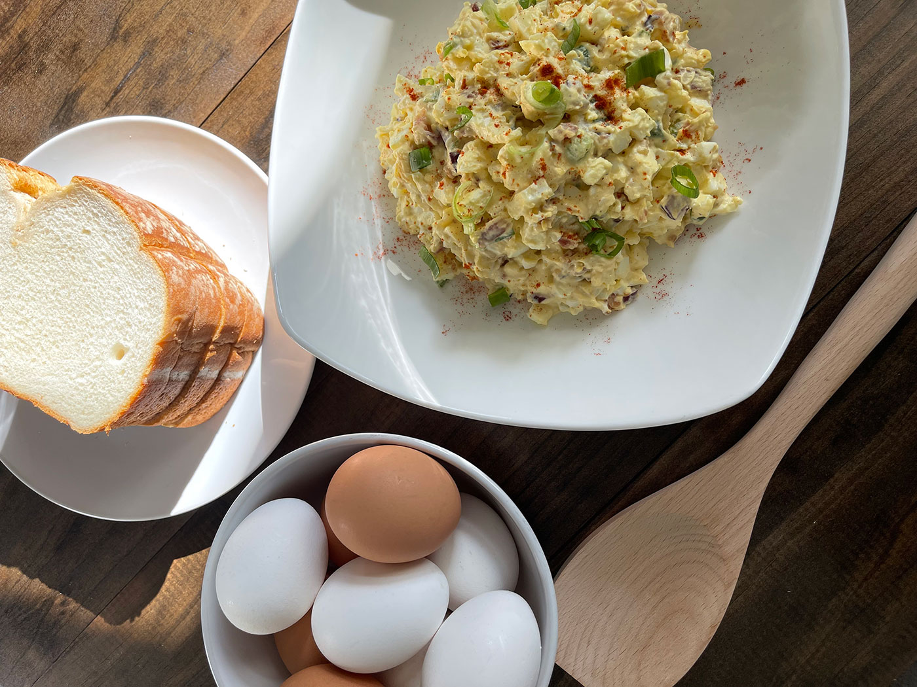
Ingredients:
Mayonnaise, more if needed | ¾ cup
Minced fresh parsley | 2 tbsp
Minced shallots | 2 tbsp
Dijon mustard | 1 tbsp
Smoked paprika | ½ tsp
Phil’s Fresh Free Range Brown Eggs | 6, hardboiled, peeled and chopped
Slices bacon, cooked and crumbled | 4
Kosher salt and freshly ground black pepper to taste | 1

Directions:
- Stir together the mayonnaise, parsley, shallots, mustard, paprika, eggs and bacon in a medium bowl. Add more mayonnaise if you prefer a creamier egg salad
- Season with salt and pepper
- Serve on croissant bread or bread of your choice

