Salted Caramel Banana Pudding
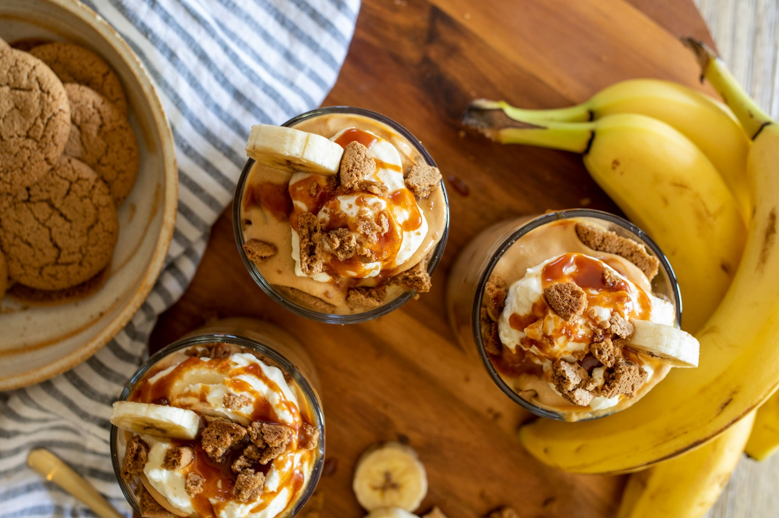

Ingredients:
White Sugar | 1 cup
Water | ½ cup
Kosher Salt | 1 tsp
Heavy cream | 3 cup
Whole milk | 1 ½ cup
Large Phil’s Fresh Cage Free Eggs | 1
Large Phil’s Fresh Cage Free Egg Yolks | 3
Corn Starch | 3 tbsp
Butter | 5 tbsp
Vanilla Extract | 1 tbsp
Bananas, sliced | 4-5
Box Gingersnap Cookies | 1

Directions:
- In a small mixing bowl, beat together egg yolks with 1 whole egg
- Mix together the milk and heavy cream in a liquid measuring cup
- In a heavy pot, combine sugar, water and salt. Cook over medium-high heat stirring once to combine. Gently swirl the pot as the sugar cooks but do not stir. Cook 10 minutes until the sugar begins to turn a light gold brown.
- Carefully pour milk and cream mixture into the melted sugar, whisking continuously with a wire whisk. The caramel will bubble up quite a bit but will settle down.
- Temper the eggs. Remove a small amount of the hot caramel mixture and slowly pour it into the beaten eggs mixing continuously. TIP: tempering egg is a process that heats eggs slowly so that they do not cook too quickly and become lumpy when added to hot liquid.
- Mix cornstarch into the tempered egg mixture
- Pour tempered eggs back into the pot of caramel again whisking continuously.
- Cook over medium heat until the caramel begins to thicken. This should only take about 2-3 minutes.
- Remove from heat and stir in butter and vanilla.
- Strain pudding mixture through a fine mesh sieve into a metal mixing bowl or heat proof bowl. Push the liquid through with a rubber spatula and discard any lumps that might remain. This will leave you with the creamiest pudding
- Cover pudding with plastic wrap and refrigerate overnight. The plastic should be touching the surface of the pudding to prevent a skin from developing.
Tip: Pudding is the best served cold and can be covered and kept for up to 3 days in the refrigerator before serving.

