Rotisserie Chicken & Cheddar Egg Salad Sandwich
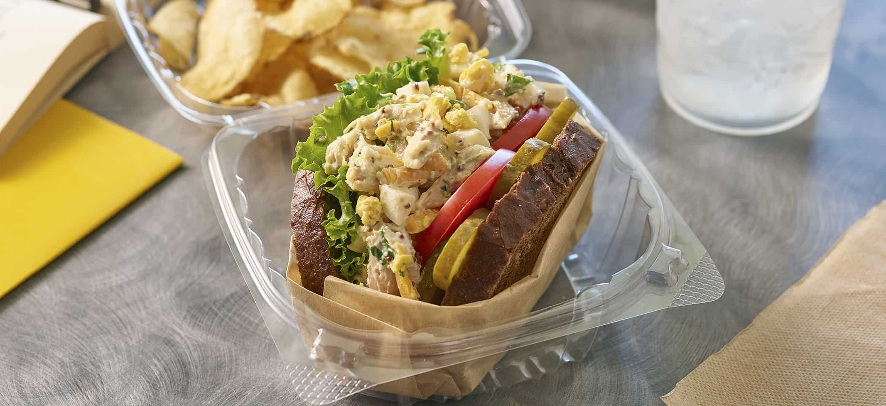
Ingredients:
Mayonnaise | 1 cup
Whole grain mustard | ¼ cup
Coarsely ground black pepper | 2 tsp
Minced garlic | 1 tbsp
Celery, small dice | 1 cup
Flat-leafed parsley, roughly chopped | ½ cup
Finely chopped green onions | ½ cups
Chopped cooked rotisserie chicken-chilled | 2 cup
Grated cheddar cheese | 1 cup
Phil’s Fresh DHA Omega-3 Large Eggs | 5

Directions:
- Prepare chicken salad: in a large bowl, use rubber spatula to work together mayonnaise, mustard, pepper, garlic, celery, parsley, and onions.
- Add chicken and cheddar cheese to bowl. Mix thoroughly with other ingredients. Taste and adjust seasoning aggressively, as flavors will be muted by bread, tomatoes, pickles, and lettuce.
- Gently fold in eggs to preserve the yolks appearance and texture
- Keep chilled until ready to use. Can be made a day ahead.

