Classic Egg Salad
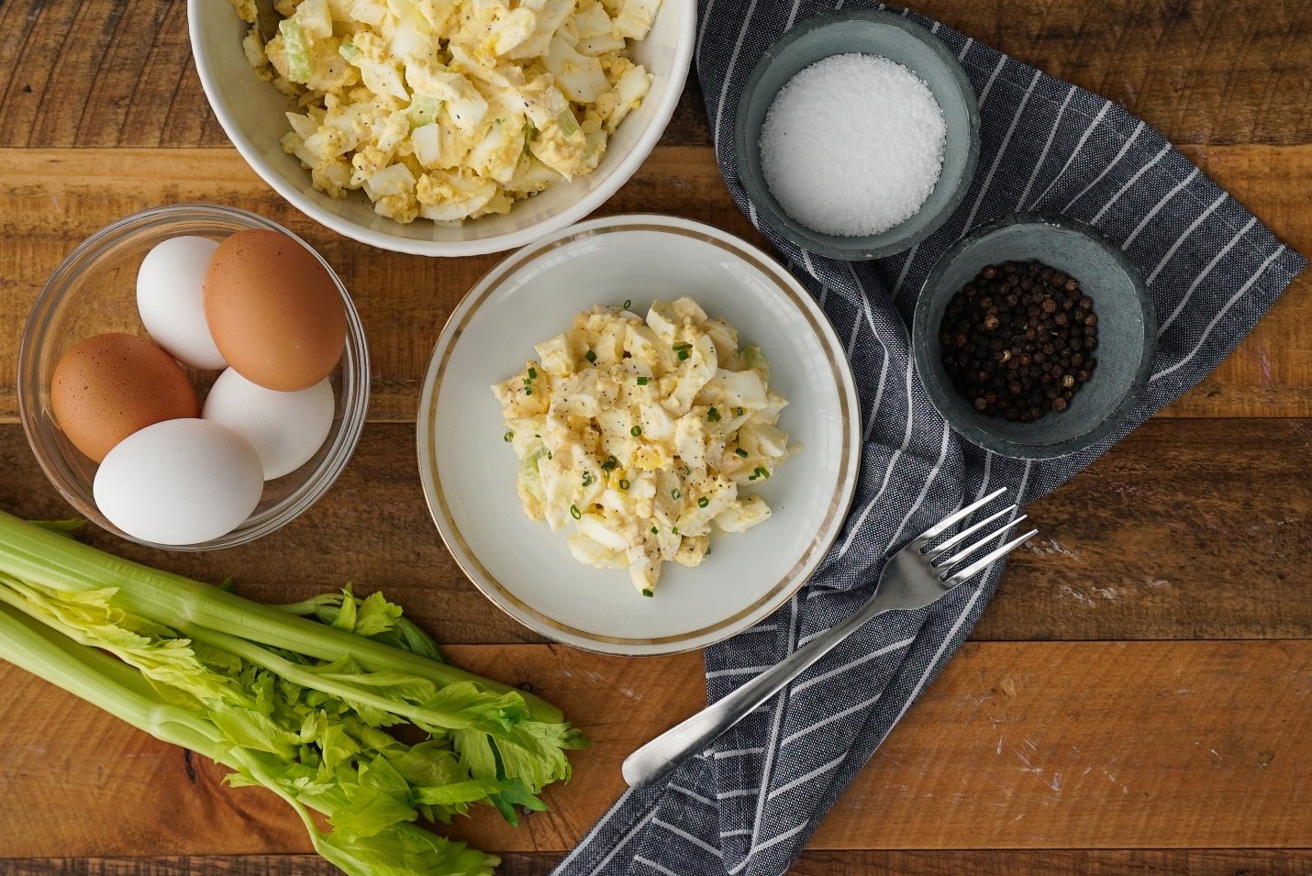
Ingredients:
Phi’s Fresh Pasture Raised Large Eggs | 6 hard boiled, sliced
Mayonnaise | ¼ cup
Fresh lemon juice | 2 tsp
Minced onion | 1 tbsp
Finely chopped celery | ½ cup
Lettuce leaves | For serving

Directions:
- Reserve and refrigerate 4 center eggs slices for garnish, if desired. Chop remaining eggs
- Mix mayonnaise, lemon juice, onion, salt and pepper in medium bowl. Add chopped eggs and celery; Mix well. Refrigerate, covered to blend flavors
- Serve on lettuce leaves, garnished with reserved egg slices
- Easy 12-minute method for hard boiled eggs: place eggs in a saucepan large enough to hold them in a single layer. Add cold water to cover the eggs by 1 inch. Heat over high heat just to boiling. Remove from the burner. Cover pan. Let eggs stand in hot water for about 12 minutes for large eggs (9 minutes for medium eggs; 15 minutes for extra large eggs). Drain. Shock the eggs in a bowl of ice water to cool them immediately. Hard-boiled eggs are easiest to peel right after cooling.

