Benedict Arnold’s Eggs Benedict
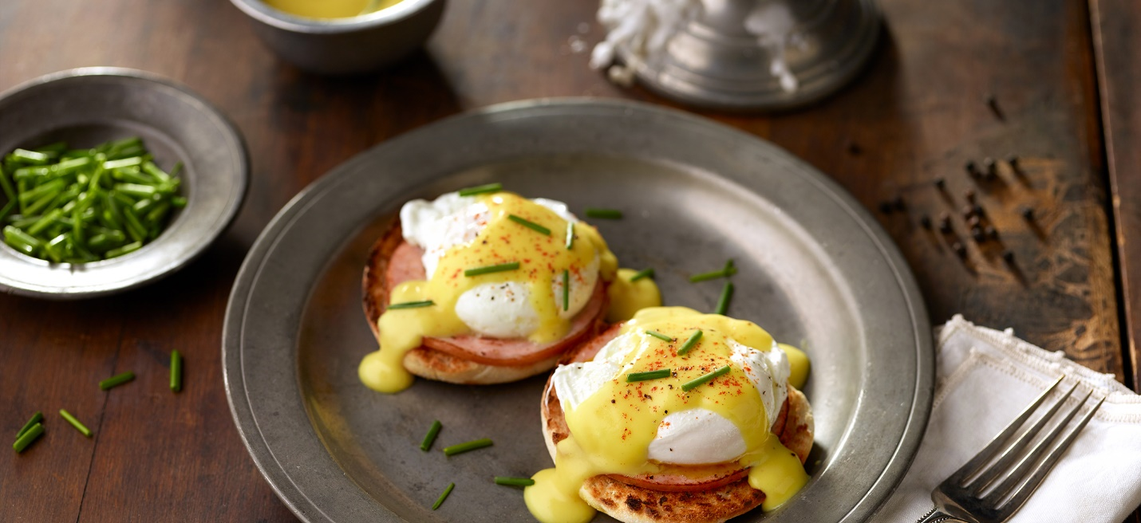
Ingredients:
Phil’s Free Range White Eggs | 8
Phil’s Free Range White Egg YOLKS | 3
Distilled white vinegar | 1 tbsp
Salt | 1 tsp. plus ¼ tsp
English Muffins, split, toasted | 4
Canadian-style bacon, warmed | 8 slices
Water | ¼ cup
Fresh lemon juice | 2 tbsp
Softened butter | 1 stick
Paprika | 1/8 tsp
Pepper | 1/8 tsp
Chives, chopped | To garnish

Directions:
- Heat 2-3 inches of water, vinegar and 1 teaspoon salt in large saucepan or deep skillet to boiling. Adjust heat to keep liquid simmering gently. Break eggs, one at a time, into small bowl. Hold dish close to surface of pan and slip egg into water
- Cook eggs until whites are completely set and yolks begin to thicken but are not hard, 3-5 minutes. Do not stir. Lift eggs from water with a slotted spoon; Drain well on a platter lined with paper towels. Keep warm
- Whisk egg yolks, water and lemon juice in a small saucepan until blended. Cook over low heat, whisking constantly, until mixture bubbles alongside the pan. Whisk in butter until melted and sauce is thickened. Remove pan from heat. Stir in salt and paprika.
- Top each muffin half with 1 bacon slice, 1 egg and about 1 ½ tablespoons of hollandaise sauce. Garnish with chives. Serve immediately.

