Shrimp Ramen Noodle Soup

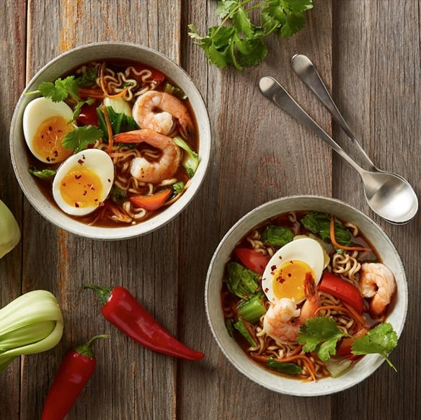

Ingredients:

|  |  |
| --- | --- |
| 2 tbsp | Olive Oil, divided |
| 1.5 lbs 41/60 count | Shrimp, peeled and deveined |
| ½ cup | Onions, chopped |
| ¾ cup | Carrots, chopped |
| ¾ cup | Red bell peppers, chopped |
| 2 cups | Bok choy, cut into 1-inch pieces |
| 2 tsp | Fresh ginger, grated |
| 4 cloves | Garlic, minced |
| 6 cups | Low-sodium vegetable broth |
| 1 tbsp | Siracha |
| 3 tbsp | Tamari |
| 2 tbsp | Brown sugar |
| 2 tbsp | Lime juice |
| 3 (3oz) packages | Ramen, seasoning packages discarded |
| 4 large | Phil’s DHA Omega-3 Eggs |
| Cilantro to serve |  |

Directions:

1. In a medium skillet, heat 1 tablespoon olive oil over medium heat. Add the shrimp and season with salt and pepper. Cook 1-2 minutes on each side, until firm and pink. Set aside.
2. In a large pot, heat 1 tablespoon olive oil over medium-high heat. Add onions, carrots, peppers and bok choy. Cook 3-4 minutes, then add ginger and garlic.
3. Add broth, sriracha, tamari, brown sugar and lime juice. Stir to combined and bring to a boil. Reduce heat and allow to simmer for 8 minutes.
4. Add the ramen noodles and shrimp. Cook for 2-3 minutes, until noodles are tender.
5. Divide among 4 bowls. Top each with eggs and fresh cilantro. Serve.