Pear-Crème Fraiche Pound Cake

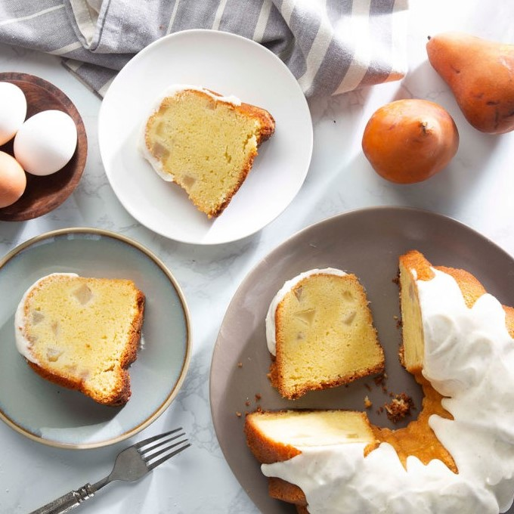

Ingredients (Pound Cake):

|  |  |
| --- | --- |
| 1 ½ cups (340 grams) | Unsalted butter, softened |
| 2 ¾ cups (550 grams) | Granulated sugar |
| 6 (300 grams) | Phil’s Free-Range Organic Eggs, room temperature |
| 2 tsp. (12 grams) | Vanilla bean paste |
| 1 ½ tsp (6 grams) | Almond extract |
| 3 cups (375 grams) | All-purpose flour |
| 1 ½ tsp (4.5 grams) | Kosher salt |
| ½ tsp (2.5 grams) | Baking soda |
| 1 ¼ cups (300 grams) | Crème fraiche, room temperature |
| 2 ½ cups (400 grams) | ½ inch-diced peeled Bosc pears* (about 3 large pears) |

Directions (Pound Cake):

1. Preheat oven to 350F (180C)
2. In the bowl of a stand mixer fitted with the paddle attachment, beat butter and sugar at low speed just until combined. Increase mixer speed to medium, and beat until fluffy, about 3 minutes, stopping to scrape sides of bowl. Add eggs, one at a time, beating well after each addition and stopping to scrape sides of bowl. Beat in vanilla bean paste and almond extract. (Mixture may look slightly curdled at this point, but batter will come together.)
3. In a medium bowl, whisk together flour, salt, and baking soda. With mixer on low speed, gradually add flour mixture to butter mixture alternatively with crème fraiche, beginning and ending with flour mixture, beating just until combined after each addition and stopping to scrape sides of bowl. Fold in pears.
4. Generously spray a 15 cup Nordic Ware Anniversary Bundt Pan with baking spray and flour. Spoon batter into prepared pan. Tap pan on counter several times to evenly spread the batter and release any air bubbles. (Pan will be quite full, but batter will not overflow during baking).
5. Bake until a wooden pick inserted near the center comes out clean and an instant-read thermometer registers 205F (96C) to 210F (98C), 1 hour and 10 minutes to 1 hour and 20 minutes, rotating pan halfway through baking and loosely covering with foil to prevent excess browning, if necessary. Let cool in pan for 20 minutes. Using a small offset spatula, gently loosen cake from center and edges of pan. Invert cake onto a wire rack, and let cool completely.
6. Spoon and spread Vanilla-Crème Fraiche Glaze onto cooled cake as desired. Serve immediately, or let stand until glaze is set, about 15 minutes

Ingredients (Vanilla-Crème Fraiche):

|  |  |
| --- | --- |
| 1 ½ cups (18 grams) | Confectioners sugar |
| 3 tbsp (45 grams) | Crème fraiche |
| 1 tsp (6 grams) | Vanilla bean paste |
| ¼ tsp | Kosher salt |
| 5 tsp (25 grams) | Heavy whipping cream |

Directions (Vanilla-Crème Fraiche):

1. In a medium bowl, stir together confectioners sugar, crème fraiche, vanilla bean paste, and salt. Add cream until mixture is smooth and thick but can be drizzled off a spatula. Use immediately.