Egg and Veggie Rice Bowl

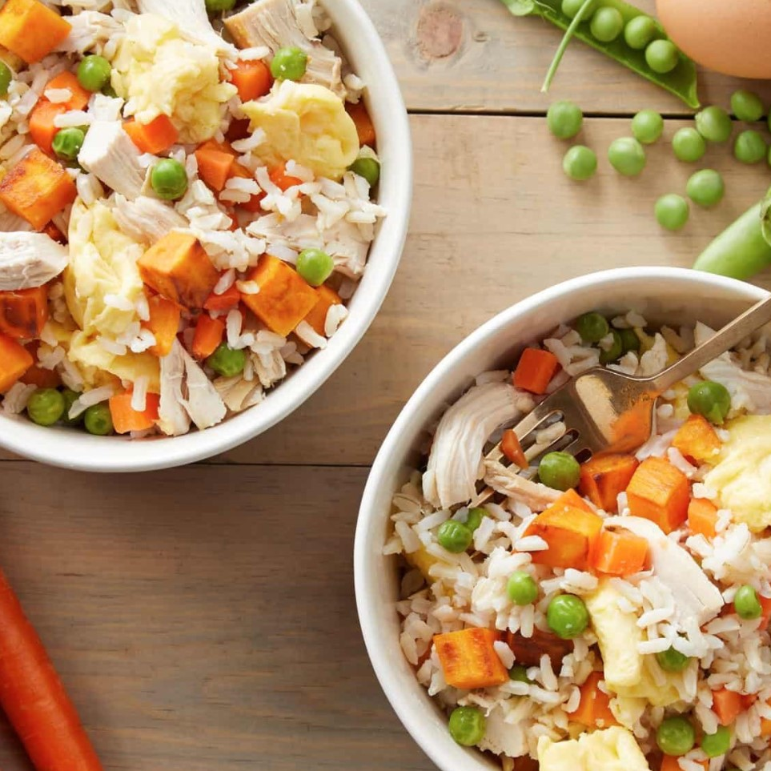

Ingredients:

|  |  |
| --- | --- |
| 1 cup | Brown rice |
| 1 tbsp | Olive oil |
| 2 cups | Sweet potato, peeled and diced |
| 2 cups | Frozen peas and carrots |
| 2 cups | Cooked chicken, diced or shredded |
| 4 | Phil’s Large DHA Omega-3 eggs |

Directions:

1. Prepare rice according to package instructions. Set aside.
2. In a large skillet over medium heat, add oil. Once warmed, add sweet potato. Cook until tender, about 7-8 minutes. Add peas, carrots, chicken and cooked rice, about 3-4 minutes. Remove to a bowl.
3. In the same skillet over medium heat, spray with nonstick cooking spray. Pour eggs into skillet. Once edges start to cook, use spatula to pull edges to the center. Repeat movement until eggs are completely cooked, about 3-5 minutes.
4. Add rice mixture back to skillet and gently fold to combine.
5. Refrigerate leftovers up to 3 days