Daredevil’s Impossible Cake

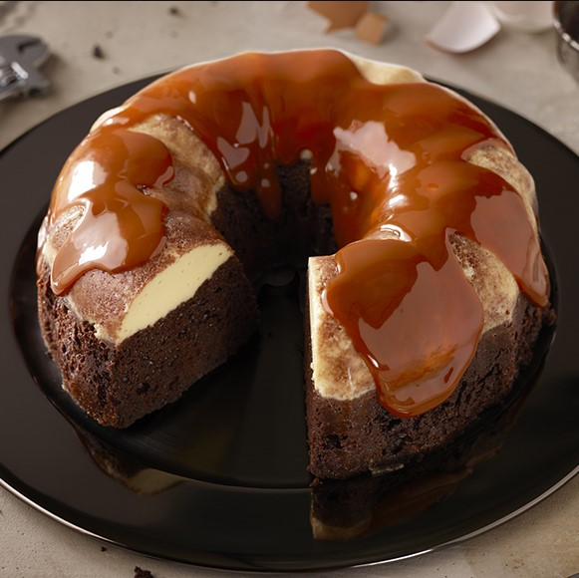

Ingredients:

|  |  |
| --- | --- |
| 7 | Phil’s Fresh Free Range Organic Large Eggs |
| ½ cup | Cajeta (Mexican caramel sauce) |
| 1 | Box chocolate fudge cake mix (15.25 oz) |
| 1 ½ tbsp | Ground cinnamon |
| 1 ¼ cups | Water |
| ½ cup | Vegetable oil |
| 1 cup | Low fat milk |
| 1 | 14 oz can sweetened condensed milk |

Directions:

1. Preheat oven to 350F. Spray a 12 cup Bundt pan with nonstick cooking spray
2. Spread ½ cup of cajeta in bottom of pan. In a mixing bowl, add cake mix, cinnamon, water, oil, and 3 eggs. Mix until all ingredients are well combined. Pour mixture into prepared Bundt pan.
3. Place remaining eggs, milk and condensed milk in a blender container. Blend for 10 seconds or until all ingredients are mixed completely. Pour mixture batter.
4. Cover bundt cake pan loosely with aluminum foil and place in a roasting dish. Place in center oven rack and fill roasting dish with 1-inch of boiling water. Bake for 48-50 minutes or when tested with a knife, it comes out clean.
5. Remove from the oven and water bath. Uncover and let cool for at least 2 hours
6. Place a large cake plate over bundt pan. Invert quickly and remove pan. Top with more cajeta sauce. Slice and serve.