Carrot Cake Mini Stacks with Cream Cheese Frosting

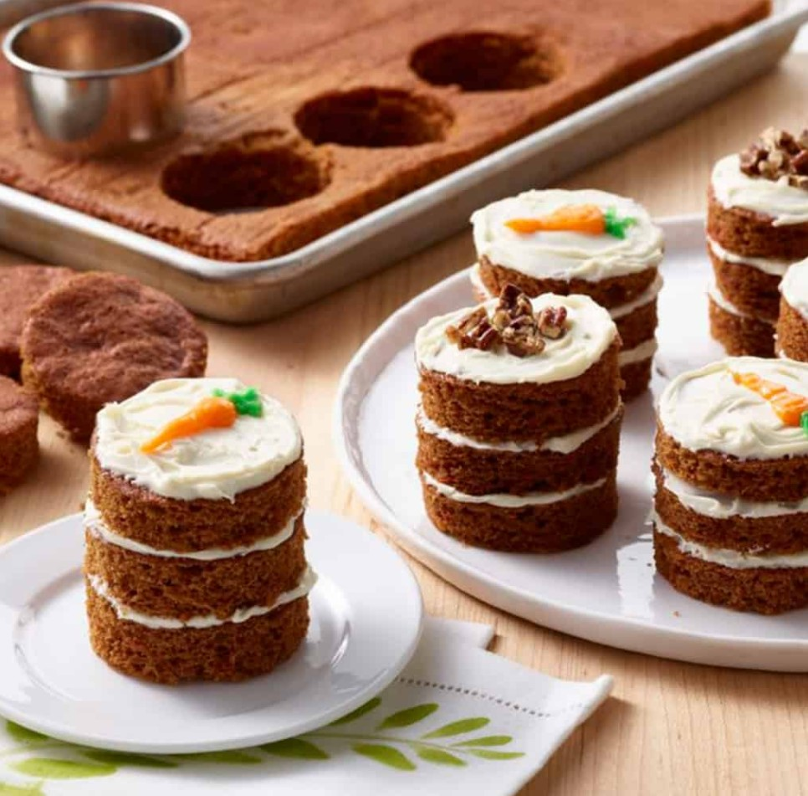

Ingredients:

|  |  |
| --- | --- |
| 4 | Phil’s Free Range Eggs |
| 2 cups | Sugar |
| 8 oz | Strained carrots (baby food) |
| 2 tsp | Cinnamon |
| Pinch | Nutmeg |
| Pinch | Cloves |
| 2 tsp | Baking soda |
| 2 tsp | Baking powder |
| 3 cups | Flour |
| ¼ tsp | Salt |
| 1 cup | Canola oil |
| 2 tsp | Vanilla |
| 4 oz | Unsalted butter, softened |
| 4 oz | Cream cheese, softened |
| 2 cups | Powdered sugar |
| 1 tsp | Vanilla extract |

Directions:

1. Preheat oven to 350F and spray a 13” x 18” sheet pan with rolled edges with cooking spray
2. In a medium bowl, sift the dry ingredients together
3. Cream sugar and eggs in a large bowl. Mix in carrots until well blended. Alternately, add the flour mixture and the oil starting and ending with the flour mixture. Mix in vanilla.
4. Pour into sheet pan and bake for 20 minutes or until inserted toothpick comes out clean.
5. Remove from oven and let cool. Cut out 18 round circles with a 3” biscuit cutter. Assemble 3 cake circles at a time by frosting the top of one, then layering a second circle on top of the first and frosting the top of the second, repeat same steps for the third. Decorate tops of mini cakes as desired.
6. Frosting: Beat together the butter and cream cheese with an electric mixer. With the mixer on low speed, add the powdered sugar a cup at a time until smooth and creamy. Add vanilla and mix till blended.