Brown Sugar Pecan Pie

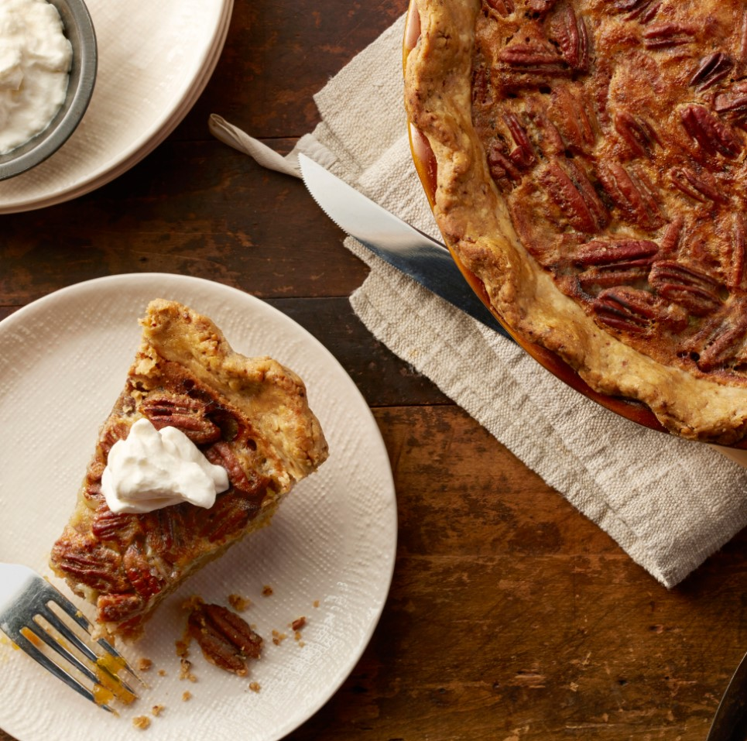

Ingredients:

|  |  |
| --- | --- |
| 3 Large | Phil’s Fresh Free Range Eggs |
| 1 cup | Packed dark brown sugar |
| ½ cup | Granulated sugar |
| 1/3 cup | Butter (2/3 stick), melted |
| 1 tsp | Vanilla |
| ½ tsp | Salt |
| 1 cup | Pecan halves |
| 1 | Basic pie crust (9-inch), baked |

Directions:

1. Heat oven to 350F. Beat eggs, brown sugar, granulated sugar, butter, vanilla and salt in a medium bowl until well blended.
2. Arrange pecan halves evenly in bottom of pie crust. Slowly pour egg mixture over pecans.
3. Bake in the center of 350F oven until knife inserted midway between center and edge of pie comes out clean, 40-45 minutes. Cool on wire rack.