Breakfast Burrito Panini

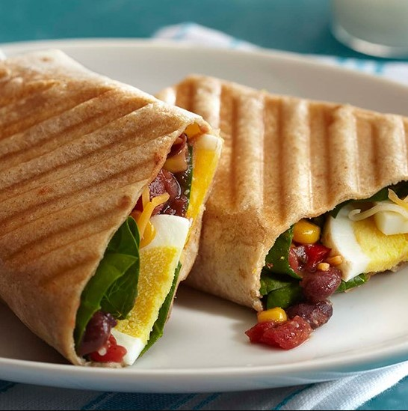

Ingredients:

|  |  |
| --- | --- |
| 2 | Phil’s Fresh Free Range Organic Eggs- Hard boiled, sliced or chopped |
| 2 | Whole wheat or flour tortillas (8-inch) |
| ½ cup | Baby spinach leaves |
| 1/3 cup | Black bean and corn salsa |
| ¼ cup | Shredded Mexican cheese blend (1 oz) |

Directions:

1. Heat panini press according to manufacturer’s directions.
2. Place one egg in middle of each tortilla; top evenly with spinach, salsa and cheese. Fold sides of tortillas over filling; fold up bottom edge and roll up
3. Grill burritos in panini press, on medium-high heat, until tortillas are toasted and filling is heated through, about 3 minutes.
4. Easy 12 minute method for hard-boiled eggs: place eggs in a saucepan large enough to hold them in a single layer. Add cold water to cover the eggs by 1 inch. Heat over high heat just to boiling. Remove from burner. Cover pan. Let eggs stand in hot water for about 12 minutes for large eggs (9 minutes for medium eggs; 15 minutes for XL eggs) Drain. Shock the eggs in a bowl of ice water to cool them immediately. Hard-boiled eggs are easiest to peel right after cooling.